1.

create TABLE Employee

(FName Varchar(30), Minit varchar(2), LName VARCHAR(30),

SSN varchar(20) PRIMARY KEY, BDate DATE,

Address VARCHAR(50), SEX VARCHAR(2),

Salary INT,

SuperSSN varchar(20), DepNo int,

Foreign Key(SuperSSN) REFERENCES Employee

);

select * from Employee;

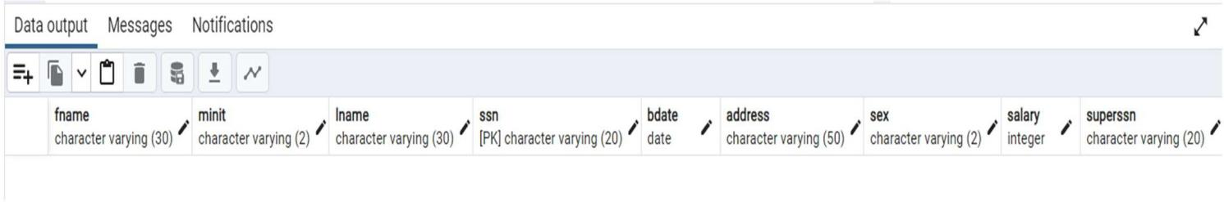

2.

create table Department(DName VARCHAR(25),DepNo int PRIMARY KEY,MgrSSN VARCHAR(30), MgrSDate date,FOREIGN kEY(MgrSSN) REFERENCES Employee);

select * from Department;

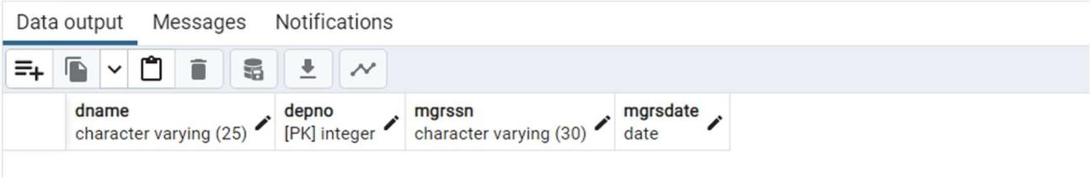

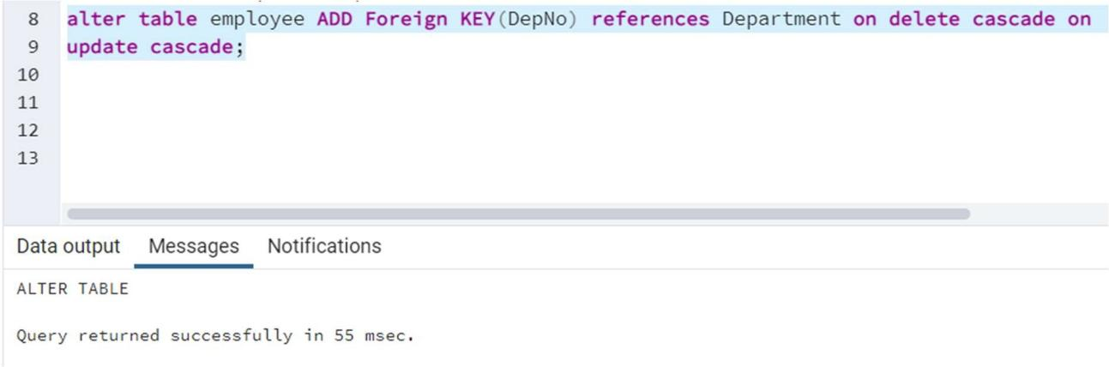

3.

create table Dept_Locations(DepNo int,DLocation VARCHAR(30),PRIMARY KEY(DepNo,DLocation), Foreign KEY(DepNo) references Department);

select * from Dept_Locations;

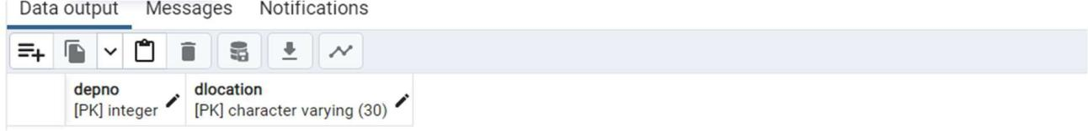

4.

create table Project(PName varchar(50), PNumber int , PLocation varchar(30), DeptNo int);

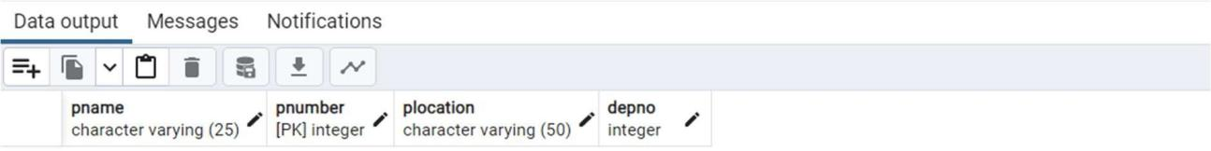

5.

CREATE TABLE Works_On(ESSN varchar(20),PNo int,Hours NUMERIC(3,1), FOREIGN KEY(ESSN)references Employee,FOREIGN KEY(PNo) references Project);

select * from Works_On;

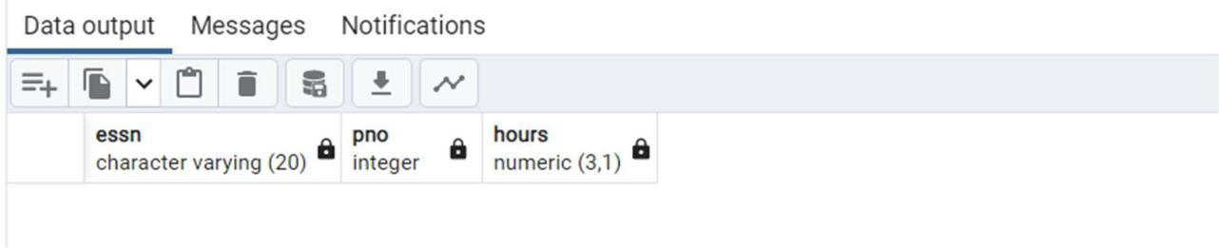

6.

CREATE TABLE Dependant(ESSN varchar(20),Dependent_Name varchar(30),Sex varchar(2),BDate date,

Relationship varchar(40),PRIMARY KEY(ESSN,Dependent_Name),Foreign key(ESSN)references Employee);

select * from Dependant;

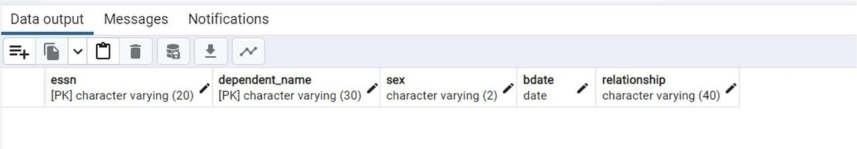

7.

INSERT INTO Employee VALUES

('James','E','Borg','888665555','10-NOV-27','450 Stone, Houston, TX','M',55000,null,null),

('Franklin','T','Wong','333445555','08-DEC-45','638 Voss, Houston, TX','M',40000,'888665555',null),

('Jennifer','S','Wallace','987654321','20-JUN-31','291 Berry, Bellaire, TX','F',43000,'888665555',null),

('Jared','D','James','111111100','10-OCT-1966','123 Peachtree, Atlanta, GA','M',85000,null,null),

('Alex','D','Freed','444444400','09-OCT-1950','4333 Pillsbury, Milwaukee, WI','M',89000,null,null),

('John','C','James','555555500','30-JUN-1975','7676 Bloomington, Sacramento, CA','M',81000,null,null);

select * from Employee;

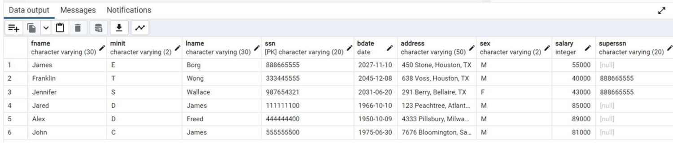

8.

INSERT INTO Department VALUES ('Research', 5, '333445555', '22-MAY-78'),

('Administration', 4, '987654321', '01-JAN-85'),

('Headquarters', 1, '888665555', '19-JUN-71'),

('Software',6,'111111100','15-MAY-1999'),

('Hardware',7,'444444400','15-MAY-1998'),

('Sales',8,'555555500','01-JAN-1997');

select * from Department;

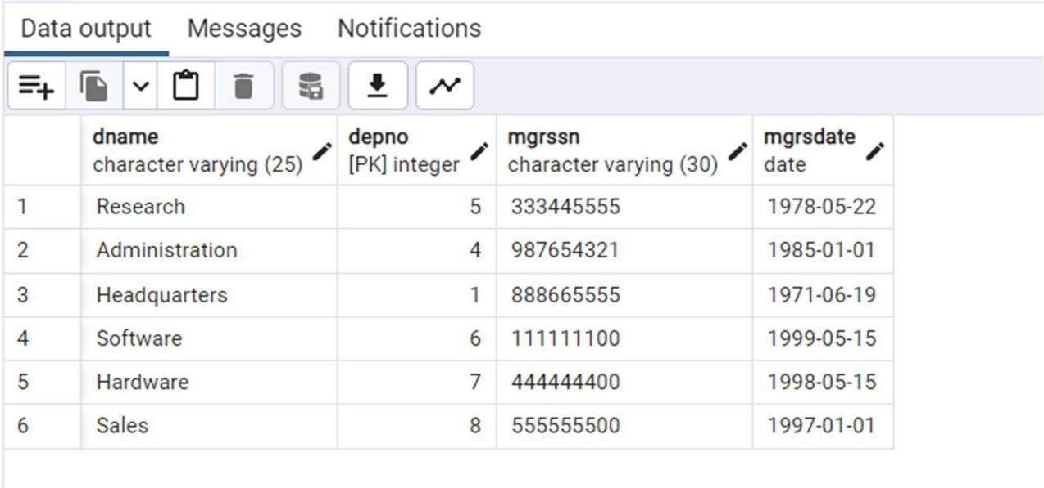

9.

UPDATE Employee SET depno = 5 WHERE ssn = '333445555'; UPDATE Employee SET depno = 4 WHERE ssn = '987654321'; UPDATE Employee SET depno = 1 WHERE ssn = '888665555'; UPDATE Employee SET depno = 6 WHERE ssn = '111111100'; UPDATE Employee SET depno = 7 WHERE ssn = '444444400'; UPDATE Employee SET depno = 6 WHERE ssn = '555555500';

select * from Employee;

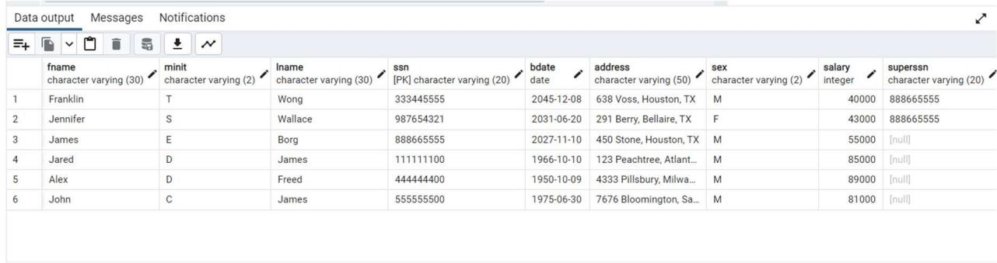

10.

INSERT INTO Employee VALUES

('John','B','Smith','123456789','09-Jan-55','731 Fondren, Houston, TX','M',30000,'333445555',5),

('Alicia','J','Zelaya','999887777','19-JUL-58','3321 Castle, Spring, TX','F',25000,'987654321',4),

('Ramesh','K','Narayan','666884444','15-SEP-52','971 Fire Oak, Humble, TX','M',38000,'333445555',5),

('Joyce','A','English','453453453','31-JUL-62','5631 Rice Oak, Houston, TX','F',25000,'333445555',5),

('Ahmad','V','Jabbar','987987987','29-MAR-59','980 Dallas, Houston, TX','M',25000,'987654321',4),

('Jon','C','Jones','111111101','14-NOV-1967','111 Allgood, Atlanta, GA','M',45000,'111111100',6),

('Justin',null,'Mark','111111102','12-JAN-1966','2342 May, Atlanta, GA','M',40000,'111111100',6),

('Brad','C','Knight','111111103','13-FEB-1968','176 Main St., Atlanta, GA','M',44000,'111111100',6),

('Evan','E','Wallis','222222200','16-JAN-1958','134 Pelham, Milwaukee, WI','M',92000,null,7),

('Josh','U','Zell','222222201','22-MAY-1954','266 McGrady, Milwaukee, WI','M',56000,'222222200',7),

('Andy','C','Vile','222222202','21-JUN-1944','1967 Jordan, Milwaukee, WI','M',53000,'222222200',7),

('Tom','G','Brand','222222203','16-DEC-1966','112 Third St, Milwaukee, WI','M',62500,'222222200',7),

('Jenny','F','Vos','222222204','11-NOV-1967','263 Mayberry, Milwaukee, WI','F',61000,'222222201',7),

('Chris','A','Carter','222222205','21-MAR-1960','565 Jordan, Milwaukee, WI','F',43000,'222222201',7),

('Kim','C','Grace','333333300','23-OCT-1970','6677 Mills Ave, Sacramento, CA','F',79000,null,6),

('Jeff','H','Chase','333333301','07-JAN-1970','145 Bradbury, Sacramento, CA','M',44000,'333333300',6),

('Bonnie','S','Bays','444444401','19-JUN-1956','111 Hollow, Milwaukee, WI','F',70000,'444444400',7),

('Alec','C','Best','444444402','18-JUN-1966','233 Solid, Milwaukee, WI','M',60000,'444444400',7),

('Sam','S','Snedden','444444403','31-JUL-1977','987 Windy St, Milwaukee, WI','M',48000,'444444400',7),

('Nandita','K','Ball','555555501','16-APR-1969','222 Howard, Sacramento, CA','M',62000,'555555500',6),

('Bob','B','Bender','666666600','17-APR-1968','8794 Garfield, Chicago, IL','M',96000,null,8),

('Jill','J','Jarvis','666666601','14-JAN-1966','6234 Lincoln, Chicago, IL','F',36000,'666666600',8),

('Kate','W','King','666666602','16-APR-1966','1976 Boone Trace, Chicago, IL','F',44000,'666666600',8),

('Lyle','G','Leslie','666666603','09-JUN-1963','417 Hancock Ave, Chicago, IL','M',41000,'666666601',8),

('Billie','J','King','666666604','01-JAN-1960','556 Washington, Chicago, IL','F',38000,'666666603',8),

('Jon','A','Kramer','666666605','22-AUG-1964','1988 Windy Creek, Seattle, WA','M',41500,'666666603',8),

('Ray','H','King','666666606','16-AUG-1949','213 Delk Road, Seattle, WA','M',44500,'666666604',8),

('Gerald','D','Small','666666607','15-MAY-1962','122 Ball Street, Dallas, TX','M',29000,'666666602',8),

('Arnold','A','Head','666666608','19-MAY-1967','233 Spring St, Dallas, TX','M',33000,'666666602',8),

('Helga','C','Pataki','666666609','11-MAR-1969','101 Holyoke St, Dallas, TX','F',32000,'666666602',8),

('Naveen','B','Drew','666666610','23-MAY-1970','198 Elm St, Philadelphia, PA','M',34000,'666666607',8),

('Carl','E','Reedy','666666611','21-JUN-1977','213 Ball St, Philadelphia, PA','M',32000,'666666610',8),

('Sammy','G','Hall','666666612','11-JAN-1970','433 Main Street, Miami, FL','M',37000,'666666611',8),

('Red','A','Bacher','666666613','21-MAY-1980','196 Elm Street, Miami, FL','M',33500,'666666612',8);

select * from Employee;

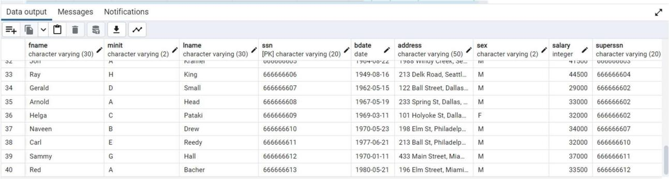

11.

INSERT INTO Project VALUES

('ProductX',1,'Bellaire',5),

('ProductY',2,'Sugarland',5),

('ProductZ',3,'Houston',5), ('Computerization',10,'Stafford',4), ('Reorganization',20,'Houston',1), ('Newbenefits',30,'Stafford',4), ('OperatingSystems',61,'Jacksonville',6), ('DatabaseSystems',62,'Birmingham',6), ('Middleware',63,'Jackson',6), ('InkjetPrinters',91,'Phoenix',7), ('LaserPrinters',92,'LasVegas',7);

select * from Project;

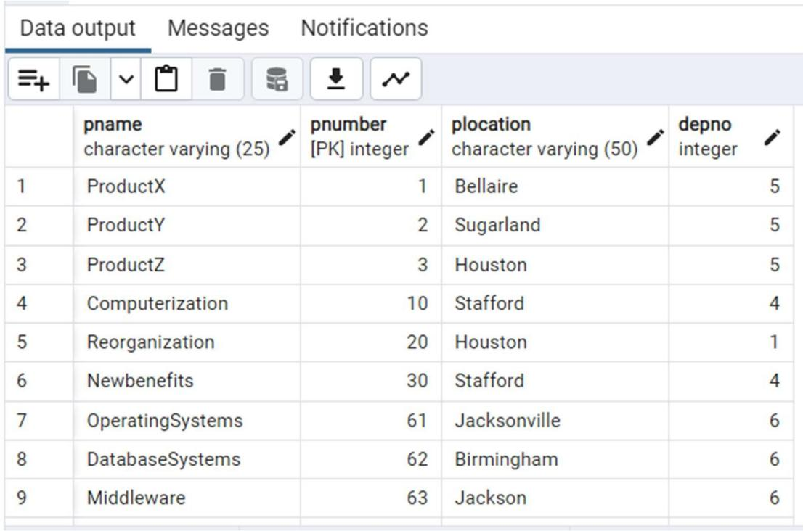

12.

INSERT INTO Dept_locations VALUES (1,'Houston'),

(4,'Stafford'),

(5,'Bellaire'),

(5,'Sugarland'),

(5,'Houston'),

(6,'Atlanta'),

(6,'Sacramento'),

(7,'Milwaukee'),

(8,'Chicago'),

(8,'Dallas'),

(8,'Seattle'),

(8,'Miami');

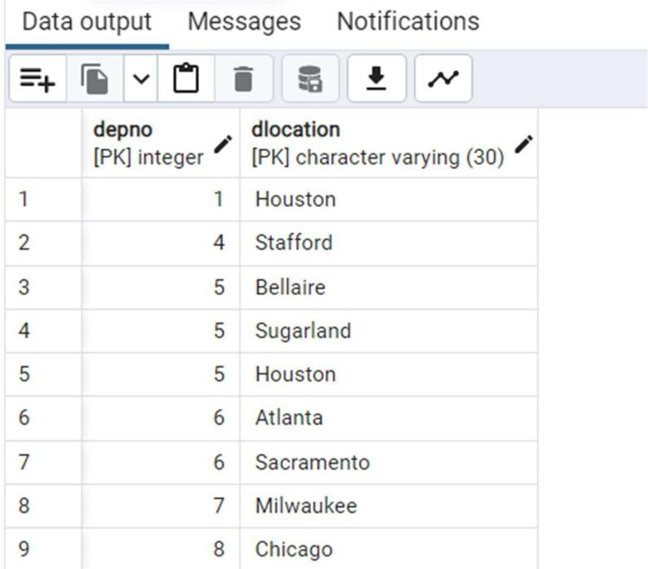

13.

INSERT INTO Dependant VALUES ('333445555','Alice','F','05-APR-76','Daughter'),

('333445555','Theodore','M','25-OCT-73','Son'),

('333445555','Joy','F','03-MAY-48','Spouse'),

('987654321','Abner','M','29-FEB-32','Spouse'),

('123456789','Michael','M','01-JAN-78','Son'),

('123456789','Alice','F', '31-DEC-78','Daughter'),

('123456789','Elizabeth','F','05-MAY-57','Spouse'),

('444444400','Johnny','M','04-APR-1997','Son'),

('444444400','Tommy','M','07-JUN-1999','Son'),

('444444401','Chris','M','19-APR-1969','Spouse'),

('444444402','Sam','M','14-FEB-1964','Spouse');

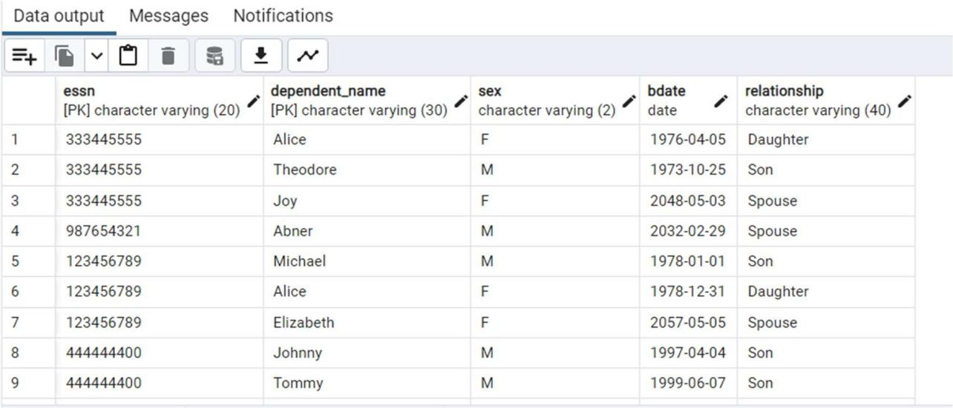

14.

INSERT INTO Works_On VALUES ('123456789',1, 32.5),

('123456789',2, 7.5),

('666884444',3, 40.0),

('453453453',1, 20.0),

('453453453',2, 20.0),

('333445555',2, 10.0),

('333445555',3, 10.0),

('333445555',10,10.0),

('333445555',20,10.0),

('999887777',30,30.0),

('999887777',10,10.0),

('987987987',10,35.0),

('987987987',30, 5.0),

('987654321',30,20.0),

('987654321',20,15.0),

('888665555',20,null),

('111111100',61,40.0),

('111111101',61,40.0),

('111111102',61,40.0),

('111111103',61,40.0),

('222222200',62,40.0),

('222222201',62,48.0),

('222222202',62,40.0),

('222222203',62,40.0),

('222222204',62,40.0),

('222222205',62,40.0),

('333333300',63,40.0),

('333333301',63,46.0),

('444444400',91,40.0),

('444444401',91,40.0),

('444444402',91,40.0),

('444444403',91,40.0),

('555555500',92,40.0),

('555555501',92,44.0),

('666666601',91,40.0),

('666666603',91,40.0),

('666666604',91,40.0),

('666666605',91,40.0),

('666666606',91,40.0),

('666666607',61,40.0),

('666666608',62,40.0),

('666666609',63,40.0),

('666666610',61,40.0),

('666666611',61,40.0),

('666666612',61,30.0),

('666666613',61,10.0),

('666666613',62,10.0);

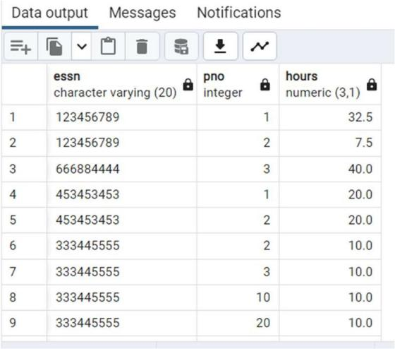

15.

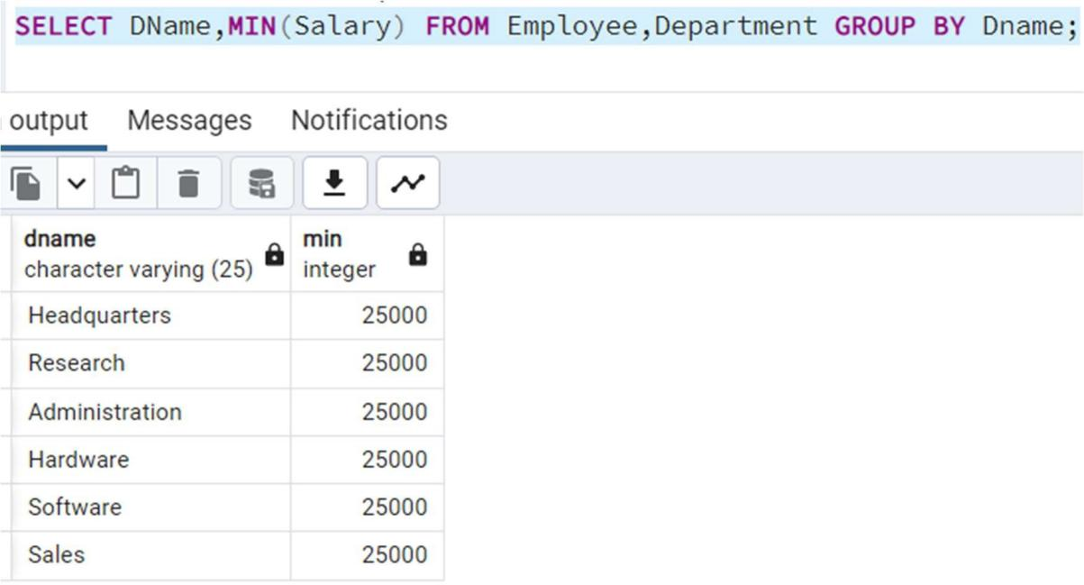

16.

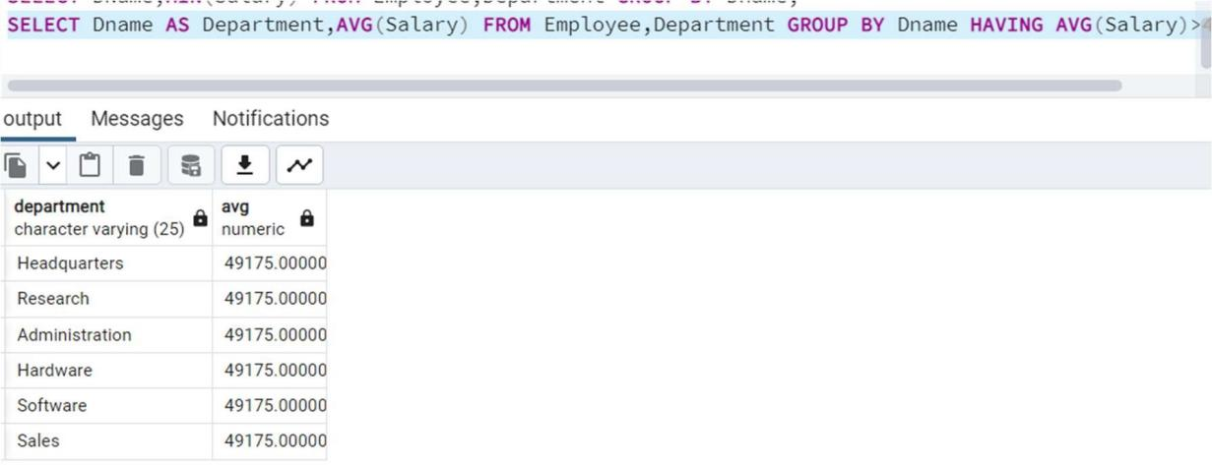

17.

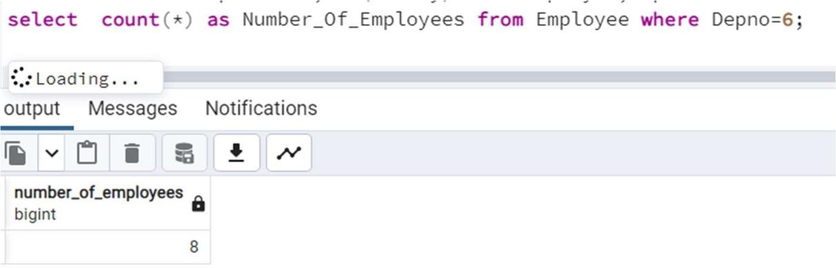

18.

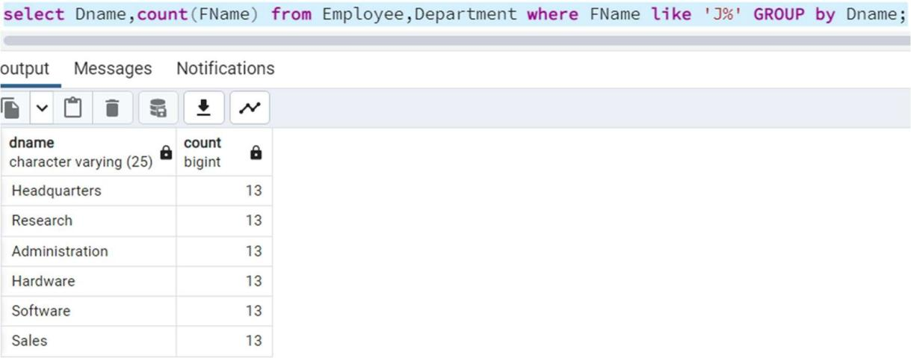

19.

